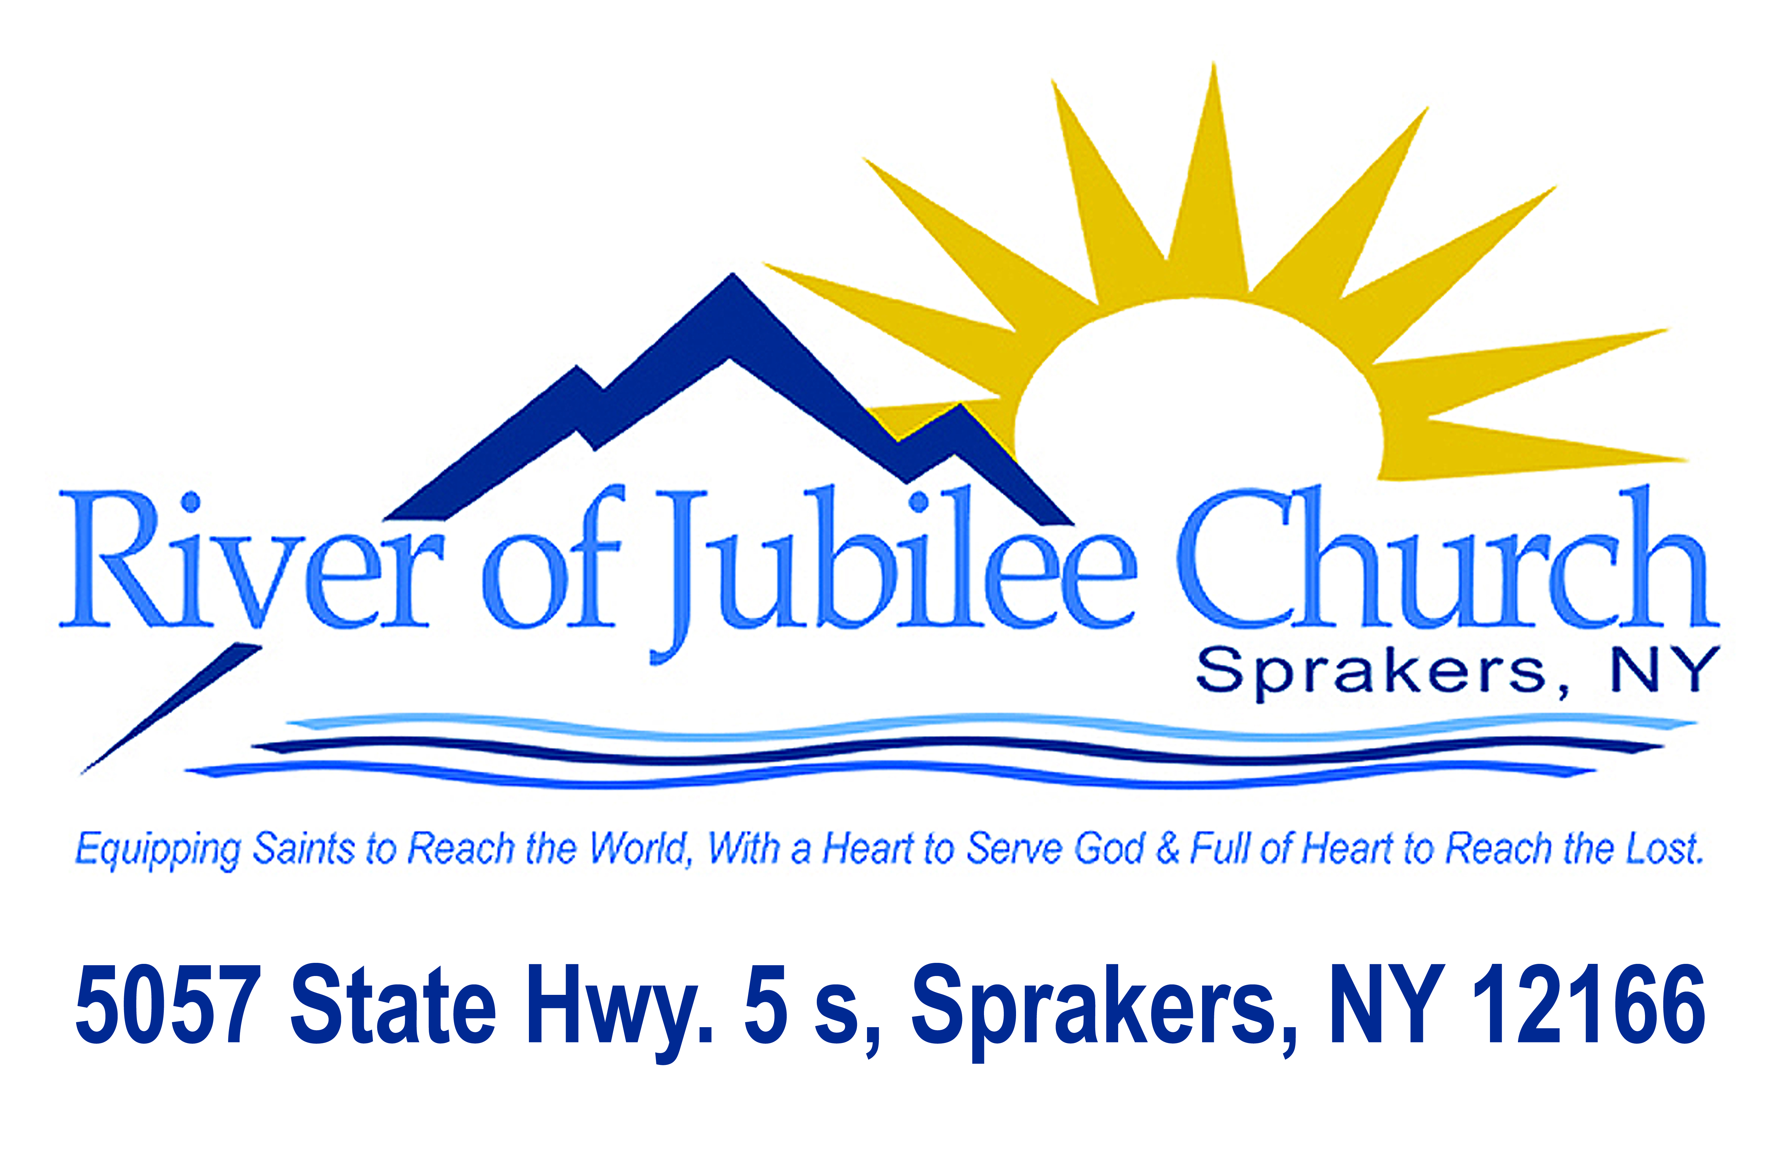
WE BELIEVE
God is one God, manifested in three Persons - the Father, Son, and Holy Spirit.
The Bible is the inspired, eternal, and infallible Word of God.
The new birth is necessary for all. Salvation is by grace through faith.
The Baptism of the Spirit is a subsequent experience to salvation for all believers and makes available all nine gifts of the Spirit.
The five-fold ministry gifts of the apostle, prophet, evangelist, pastor, and teacher are for the equipping of the saints in the Body of Christ today.
The Redeemed will enjoy eternal life in heaven with Jesus their Savior while the Lost will spend eternity in the lake of fire separated from God's presence. Christ's return for His Bride is imminent, and after tribulation, He will rule on earth during the Millennium.
The Great Commission is to be fulfilled by the Church going and preaching, and making disciples of all nations.
Sanctification is a definite, yet progressive, work of the Spirit commencing at rebirth and continuing until the consummation of salvation.
Water baptism is by immersion and is for believers only as an identification with Christ's death, burial, and resurrection unto new life.
Divine healing is provided for by the work of Christ, is wrought by the power of God and is for the physical, spiritual, and emotional wholeness of each person.
The Lord's Supper (Communion) is to be partaken of regularly, served in a spirit of love toward His Body, and shows the Lord's death until He returns.

